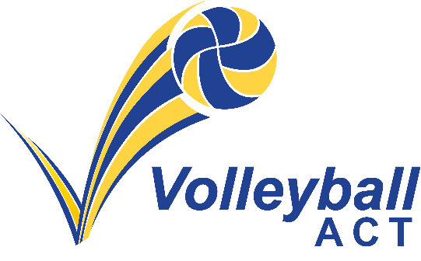
Volleyball ACT Strategic Plan – 2023 to 2025

Vision:
Be a leader in the growth and development of Volleyball.

VACT Mission:
Enable volleyball players, coaches and officials and volunteers from the ACT to achieve their aspirations through Volleyball. By developing, enhancing, and maintaining volleyball opportunities, in line with the VACT values.

VACT Values:
- Inclusivity: Providing everyone the opportunity to be involved in Volleyball
- Commitment: Showing commitment to the development and maintenance of the sport.
- Respect: Valuing everyone’s role in the sport
- Excellence: Striving for holistic excellence within the sport
- Integrity: In policy, delivery, and transparency in all processes

Performance | Participation | Govern | Profile
To provide performance development opportunities | Providing opportunities to participate via new, existing and inclusive program | Sound governance and financial practices through effective leadership | Increase the profile of volleyball in the community
Success Measures (Strategies)
1.1. Establish and provide pathways for athlete, coach, and officials development | 2.1. Well organised, effective, and expanded competitive opportunities in volleyball | 3.1 Establish periodic and systematic review of policies and procedures | 4.1 Maintain and develop meaningful engagement with community connections
1.2. Provide opportunities and development for High Performance athletes, coaches, and officials | 2.2. Grow the volleyball participation base through expansion and inclusivity programs | 3.2 Ensure VACT community are aware and uphold VACT’s values, culture, and integrity policies | 4.2 Develop and implement a digital and content marketing strategy
1.3 Develop and maintain resources to ensure sustainable performance opportunities | 2.3 Increase the diversity and inclusion within our community | 3.3 VACT adequately protects itself from risk | 4.3 Increase and develop the venue experience and profile of the Lyneham Beach Facility
 | 2.4 Develop a school volleyball strategy | 3.4 VACT attracts and maintains the right team | 4.4 Improve the indoor volleyball venue experience
 |  | 3.5 Ensure financial stability
Major Initiatives
 | Further investment in Indoor infrastructure
 | Development pathways for Official and coaches
 | Strategic planning focus on
 | Collaboration and adoption of RAP
 | Continue to grow school sport program & support club growth
 | Cyclical review of corporate documents and policies to ensure compliance and best practice.

